1. Go to wifi settings: (right click) first option:

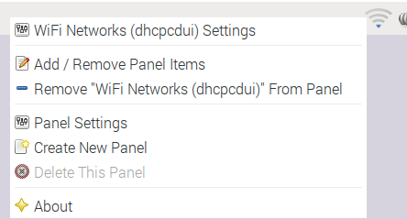

1. Choose interface and network

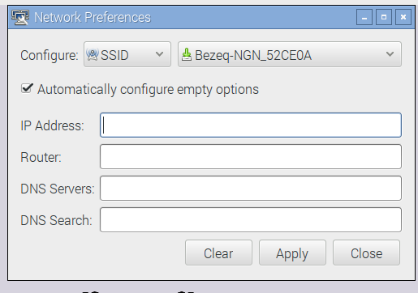

1. Write IP address (my desired was 10.0.0.100) and hit apply.
2. Reboot and try
3. You can verify with cat /etc/dhcpcd.conf (last of file has name and static ip)

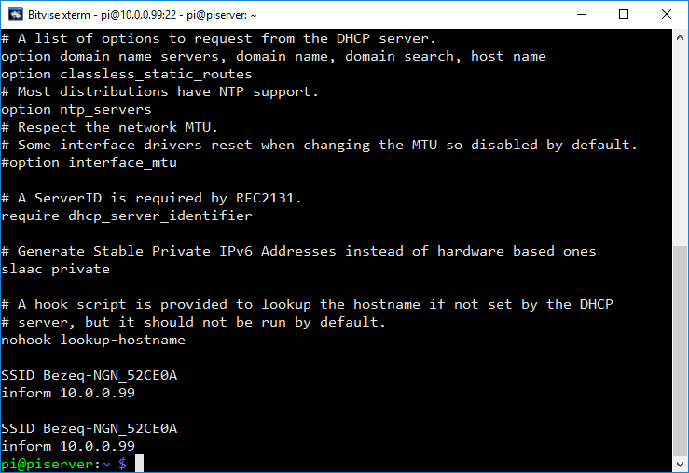

1. Each apply add rows to end of file so delete with nano if you want

